BASHSCRIPTING

1. CREATED DIRECTORIES

Mkdir -p /Pallavi/scripts/

1. Changed Directory from root to /Pallavi/scripts
2. Created Scripts, changed permissions and executed to run

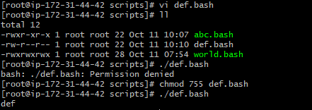

1. Script format _ Defined shell, comments , variables & statements(need to change variable value)

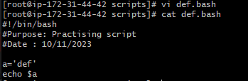

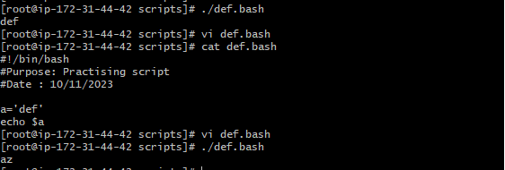

SCRPIT INPUT & OUTPUT IS SAME

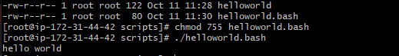

BASIC SECOND SCRIPT

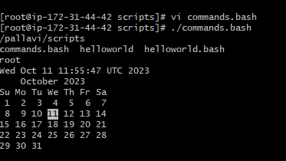

**BASIC ADMISTRATION TASKS**

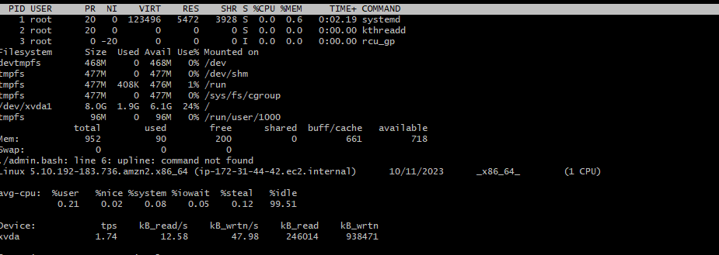

**VARIABLES SCRIPT**

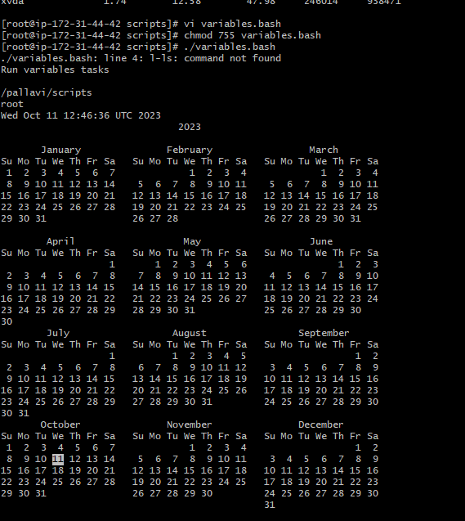

**INPUT/OUTPUT SCRIPT**

